**Development of Aromatix, a Computational Tool for Determining Aromaticity**

**Patrick Schloesser**

Professor Daniel J. O’Leary, Advisor

Chemistry Department

Pomona College

November 2019

Submitted in Partial Fulfillment of the Requirements

for the Degree of Bachelor of Arts in Chemistry

Table of Contents

Introduction 2

Aromaticity 2

Structural Criteria 3

Energetic Criteria 4

Magnetic Criteria 5

Aromaticity Assay 6

User Interaction 7

Program Behavior 8

Methods and Materials 11

User Interface 11

Data Parsing 14

Connectivity Organization 15

Horton’s Algorithm 18

Determine the Shortest Path between Every Combination of Two Nodes 18

Determine All Cycles within the Graph 21

Sort the Cycles by Weight 23

Minimum Cycle Basis Determination 23

Edge Cases 24

Centroid Identification and Dummy Atom Placement 26

Axial Dummy Atom Placement 27

Gaussian Input File Generation 30

Packaging the Program for Users 31

Results 32

Centroid Identification and Probe Proton Placement 32

Gaussian NMR Input File Creation and NICS Results 35

Discussion and Conclusions 38

Centroid Detection, Cycle Identification, and Dummy Atom Placement 38

Input File Generation and NICS Determination 40

Future Work 41

Acknowledgements 43

References 44

NOTE: I need to insert figures and abbreviations list

# Introduction

## Aromaticity

Aromaticity is a descriptor that pervades modern chemical research and scholarship and informs manifold structural, magnetic, and energetic characteristics of the compounds it describes. Of the nearly 20 million molecules currently classified, approximately two thirds are either fully or partially aromatic; This is not to say that aromaticity is a valuable descriptor simply due to its large-scale applicability but rather that the bounds, definitions, and assignments of the aromatic identifier are immanently topical within the field of chemistry.1 The definition and use of aromaticity has a varied history that alternates with new findings and revisions to the literature. The term was first introduced by August Kekule in 1865 concomitant with his discovery of the structure of benzene. Kekule defined aromatics as organic molecules with lower quantities of hydrogen atoms in contrast to their aliphatic counterparts that have higher hydrogen density.1,2 In the following year, Erlenmeyer proposed a structural formula for naphthalene and advanced the notion that aromaticity was a reactive characteristic, defining aromatics as organic compounds that favor substitution reactions more highly than addition.1,3,4 The following centuries saw a great variety of advances in the quantification and characterization of aromaticity including cyclic conjugation and Huckel’s rule, diamagnetic susceptibility exaltation, and nucleus independent chemical shifts. 1,4,5 Since Kekule’s initial use, chemists have struggled with applying a definition to aromaticity that is reductive and exclusive particularly as early declarations of planarity, cyclic conjugation, and other qualitative features as sufficient quantifiers for establishing aromaticity were proven inadequate; However, developments in recent decades have converged into a general understanding of aromatics as planar, conjugated, and cyclic or polycyclic organic compounds with high stability, low reactivity, and low magnetic susceptibility.6,7,8 While this definition is fairly general because many antiaromatic species satisfy a majority of its requirements and many aromatics do not satisfy all, examination of structural, energetic, and magnetic characteristics of aromatics allows for the determination of a more unique and applicable identifier.5,9

### Structural Criteria

Within the structural context of a molecule, there are two distinct notions of aromaticity with their own associated properties and identifiers, two-dimensional (2D) and three-dimensional (3D) aromaticity.10 2D aromaticity refers to the aromaticity of each ring within the molecule and 3D aromaticity more generally to aromaticity experienced across the entirety of the molecule.10,11 For example, from an electronic perspective, evaluating 2D aromaticity would primarily focus on electron circulation within each ring and evaluating 3D aromaticity would inspect electron circulation over the closed surface of the molecule. Basically, 2D and 3D aromaticity specify the exact context of examination. Structurally, 2D aromaticity within a molecule is traditionally determined by examining the bond lengths of the rings within it. Aromatic species have far more equalized bond lengths within their rings as compared to antiaromatic compounds due to cyclic electron delocalization particularly in the case of archetypical aromatic compound benzene which has uniform bond lengths of 1.40 Å.4 However, while bond length equalization is a common feature among a large quantity of aromatic compounds, it is not present in all. Polymethinium, which is not aromatic, exhibits equal bond lengths across its structure, and phenanthrene, a common aromatic compound, has fairly large alternations in bond length, meaning that bond length equalization and bond length alternation (AJ, BAC) are not meaningful metrics to uniquely distinguish aromatic compounds.4 Other geometry-based metrics such as the harmonic oscillator model of aromaticity (HOMA) which measures deviation from the optimal bond length of the molecule’s hypothetical Kekule structures and harmonic oscillator stabilization energy (HOSE) which measures the amount of energy required to deform the geometry more closely predict aromaticity and antiaromaticity than bond length alternation.12 Recent studies have shown, however, that HOSE, HOMA, and other structure-based indices are not as strong indicators of aromaticity as their magnetic and energetic counterparts due to overestimation of aromatic character in species of high bond equalization and the unreliability of geometry deformation in predicting aromaticity.12–14

### Energetic Criteria

One of the earliest descriptors of aromatic compounds was greater stability than their antiaromatic counterparts as noted when Erlenmeyer posited that aromatics tend to favor substitution reactions over addition.3 This tendency to favor substitution is common among many aromatics and is indicative of higher stability as completion of substitution returns the molecule to its initial electronic structure.1 As such, many indices have been developed to measure the stabilization or resonance energy in order to determine aromaticity. Of particular importance are heat of hydrogenation, aromatic stabilization energy (ASE), and resonance energy (RE). Because stability is a relative evaluation, these indices rely on reference systems to compare with the molecule of focus in order to determine its stability within the context of that reference system. The selection of reference system can have drastic impacts on the outcome of the aromaticity assay as in the case of borazine which was determined to be between 26.9% and 121.7% aromatic when making methodologically sound selections of different reference systems.14 This inconsistency for borazine was true for both ASE and heat of hydrogenation and in general, the outcomes of aromaticity determination with stabilization-based indices often vary with reference system selection, meaning that these indices are not completely reliable for unique and specific aromaticity determination.4,14 To be clear, these stabilization-based indices in addition to the other structure-based indices referenced previously are generally effective measures that provide valuable information to researchers; however, it is important to establish their limitations particularly within the context of this study’s focus on aromaticity determination.

### Magnetic Criteria

In the presence of an external magnetic field, aromatic species tend to experience an induced electric current. This behavior occurs because aromatic molecules contain cyclically delocalized electrons which facilitate a ring current in the presence of a magnetic field.15,16,17,18 Due to different levels of occupancy in HOMO and LUMO between antiaromatic and aromatic species, aromatic compounds experience a diatropic ring current and antiaromatic molecules a paratropic ring current where paratropic and diatropic simply refer to the direction that the current travels along the cycle.15,19 As such, many indices for evaluating aromaticity take advantage of these magnetic characteristics such as magnetic susceptibility exaltation (MSE), current density analysis (CDA), and nucleus independent chemical shifts (NICS).15,20 While ring currents are not quantifiably measurable, magnetic susceptibility exaltation is and results directly from the ring current of a molecule. In aromatic species, the molecule has a higher magnetic susceptibility than the individual atoms, a difference know as exaltation that is used by MSE to form aromaticity predictions.5,15 CDA provides the direction and magnitude of the current induced within a molecule by visualization methods such as anisotropy of induced current density (ACID) and continuous transformation of origin of current density-diamagnetic zero (CTOCD-DZ).15 While this method does provide visualizations of the direction and strength of the current, it cannot provide explicit values that allow evaluation of relative aromaticity.15 Last, NICS was developed in 1996 by Schleyer et al to determine the diatropicity of rings in molecules by calculating absolute magnetic shielding about the center of each ring.21 NICS thus determines the aromaticity of the rings within a molecule by using aromatic molecules’ tendency toward induced diatropic ring currents. These various indices provide effective measurements of the magnetic character of aromaticity, but NICS is currently the most effective and widely used.15,22

## Aromaticity Assay

Especially in the context of the information already presented, aromaticity is an extremely valuable descriptor due to the various structural, energetic, and magnetic implications it provides for the molecules it describes. When examining a less-studied molecule or attempting to predict chemical behavior within a certain context, the indices associated with aromaticity provide a significant amount of information that can aid in prediction or classification. Of these myriad indices, NICS has been shown to be the most effective due to its precision in diatropicity evaluation and its widespread applicability to a variety of aromatic species.8,22–25 In particular, NICS works by plotting a point in the exact middle of each ring in a cyclic or polycyclic molecule and then evaluating the absolute magnetic shielding about that point. After performing various calculations, these shielding values give way to the NICS value which is negative if the molecule experience diatropic ring current and positive otherwise.21,23 While placing the probe protons at ring centers and calculating absolute magnetic shielding about those points is fairly simple for monocyclic and polycyclic species with few rings, calculation of NICS in large organic molecules with a large quantity of rings is laborious. As such, it is far more difficult to make use of NICS for larger organic molecules than their smaller counterparts, meaning that researching the aromatic properties of less-studied, large organic species is more difficult as well. This study intends to provide a computational tool to automate calculation of NICS values for the majority of known molecules because studies of aromaticity are valuable for supplementing chemical knowledge and NICS is currently the best analytical tool to achieve that purpose.

## User Interaction

The workflow for the computer program consists of several critical steps in terms of the user’s and the program’s behavior. In terms of the user interaction, a user performs the following:

1. The user creates the desired molecule in GaussView and computes an optimization output file using desired basis set.26
2. Aromatix takes the Gaussian output file as input and outputs a file for Gaussian to run with protons placed at ring centers.
3. The user inputs the Aromatix output file into Gaussian. Gaussian interprets the file as an absolute magnetic shielding calculation preformed at ring centers.
4. Gaussian produces an output file with the absolute magnetic shielding for each ring center
5. The user inputs the Gaussian output file into Aromatix for and receives a file holding the NICS values and final aromaticity determination.

**Figure 1.** User behavior after launching the program from selection of the input file to receiving the output file with NICS values

More specifically, the user interface for this program is relatively simple, consisting of two buttons labeled “Prepare Absolute Magnetic Shielding Calculation” and “Calculate NICS Value” (Fig. 2). To manage input and output, the user is first greeted with a window to select the input file and then prompted with an additional window to indicate where the output file should be saved (Fig 2.). Selection of “Calculate NICS Value” initiates the behavior as outlined in Step 5 (Fig 1.).

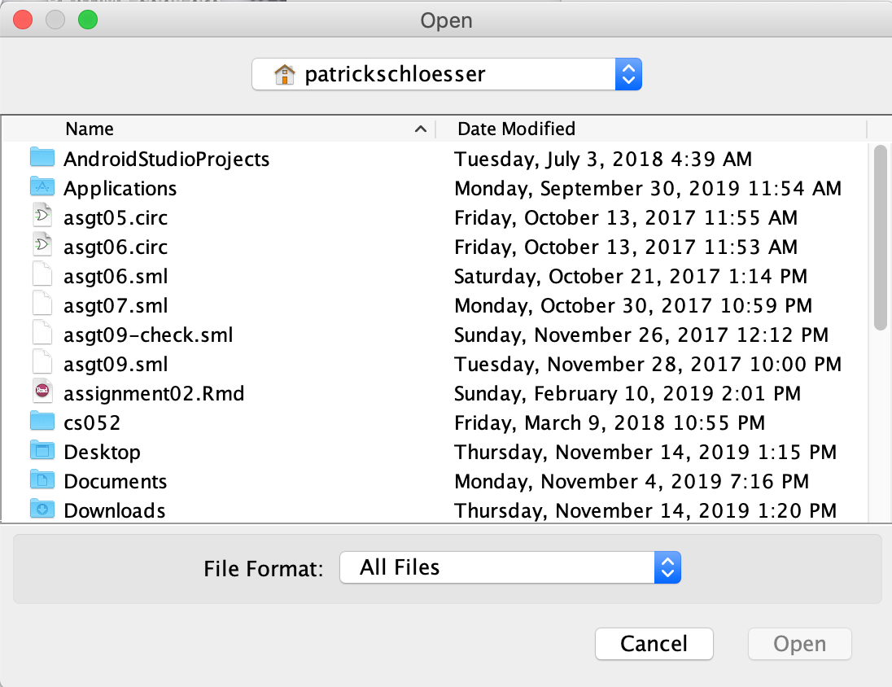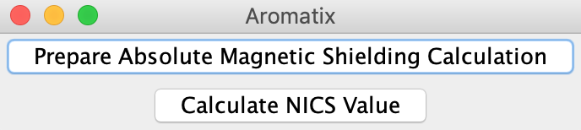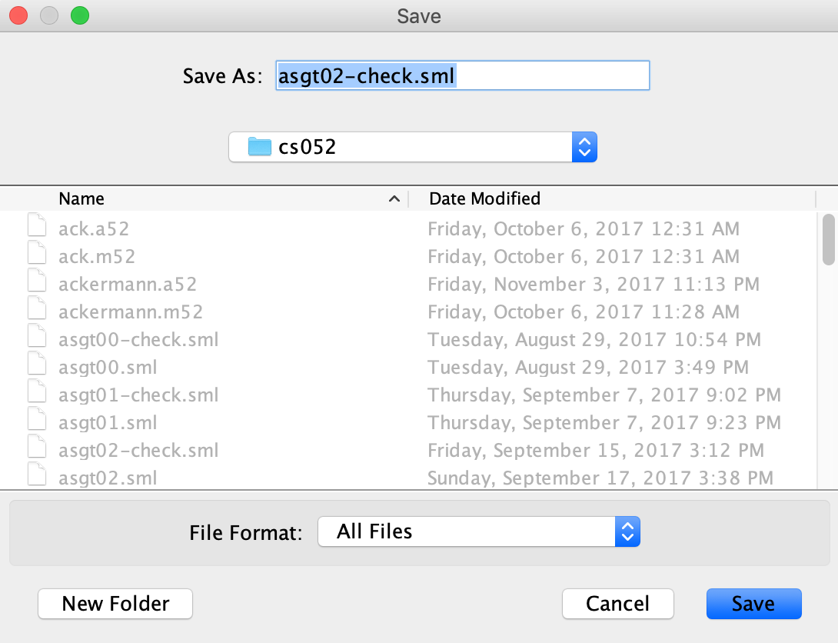**Figure 2.** User interfaces for Aromatix **A.** Initial user interface for upon running the program

B

A

**B.** Input file selection window (left) and output file saving window (right)

## Program Behavior

Programatically, the computational behavior of the software is more sophisticated. The program runs in java and was developed in Intellij IDEA. Management of Gaussian output files and creation of Aromatix output files is performed with basic java read and write mechanics via

the BufferedReader function.27,28 The BufferedReader allows line by line reading of any text file and thus easy identification of the two varieties of data used by the program. Gaussian

optimization files contain a variety of coordinate and spatial data, but of particular interest for Aromatix are the connectivity geometry and input orientation. The connectivity geometry specifies the atoms within the molecule and the type and number of bonds between them. The input orientation specifies the coordinates of each atom within a 3-dimensional space and is used for placement of the central proton probes (Fig. 3). The central programmatic task of Aromatix is using the connectivity geometry data to identify the rings within the molecule, which requires representation of the molecule’s atoms and their connecting nodes.

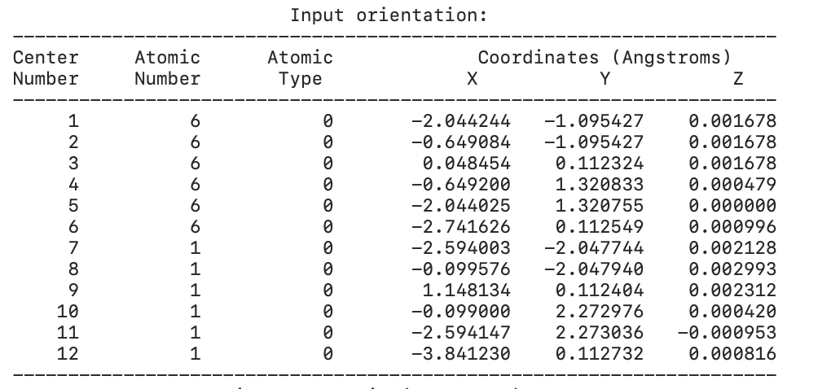After reading in the connectivity and input orientation data, Aromatix forms a graph using the connectivity geometry. In computer science, a graph G = {V,E} represents a set of nodes, V, and their edges E, the connections between them. An edge between two nodes v1 and

**Figure 3.** Input orientation and connectivity in Gaussian Optimization output file.

v2 simply refers to a connection between those two nodes and is represented by the pair (v1,v2). E is the set of all such pairs (v1,v2) for the graph G.29,30 Conversion of the connectivity data to a graph is necessary for the functioning of Aromatix because the program requires the ability to traverse the molecule for ring identification.

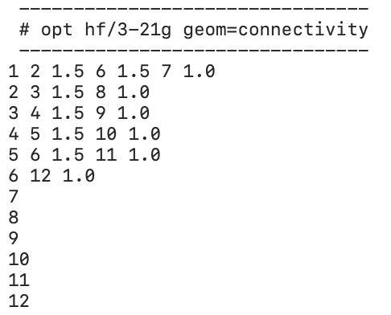 In terms of computational burden, ring identification is the most difficult and

computationally expensive behavior performed by Aromatix. Identification of rings without incorrectly identifying adjacent rings as a larger, single ring requires a variety of algorithmic methods. In graph theory, a cycle is any path that ends in itself without repeating nodes where a path P simply refers to a set of nodes V = {v1, v2, v3, … , vn}, where vi shares an edge with vi+1. For the purposes of this project, ring identification requires selection of all cycles that cannot be composed of smaller cycles, a problem in computer science known as the minimum cycle basis problem.31

A minimum cycle basis set is the set of the cycles within a graph that can be used to compose all other cycles. For the purposes of calculating magnetic shielding, the molecular rings of focus are those that cannot be subdivided into smaller rings, basically the set of rings that can be used to compose all others in the molecule. For example, bicyclo [2,2,1] heptane has two adjacent rings that compose a larger cycle, but these two indivisible rings are the only ones of focus because they compose all others in the system. As a result, calculation of the minimum cycle basis set will identify all rings within the system, allowing placement of probe protons at their centers. Minimum cycle basis set calculation proceeds according to Horton’s algorithm32 (Fig. 4).

1. For every pair of vertices (x,y) compute the shortest path P(x,y) between the two vertices.
2. For every combination of each vertex v with every edge (x,y), compute P(x,v) and P(y,v). If the intersection of sets P(x,v) and P(y,v) contains only the node v, then a cycle exists and is added to a list of cycles.
3. Order the cycles by weight.
4. Using Gaussian elimination, determine the set of cycles that are linearly independent from one another. This is the minimum cycle basis.

**Figure 4.** Horton’s algorithm for determining a minimum basis set for a graph G = {V,E}

Upon determining the minimum cycle basis set, all rings within the molecule have been identified. Dummy protons are placed along the axes of the geometric center of each ring using the coordinates associated with the atoms forming each ring. These new protons are added to the Gaussian input file submitted by the user.

After the user submits the new Gaussian input file and receives an output file with the absolute magnetic shielding values, the user submits that outputfile to Aromatix for calculation of NICS values. NICS values are simple arithmetic manipulations of the absolute magnetic shielding with little computational expense. The results of aromaticity determination are written to an output file for user interpretation, completing the workflow of the program.

# Methods and Materials

## User Interface

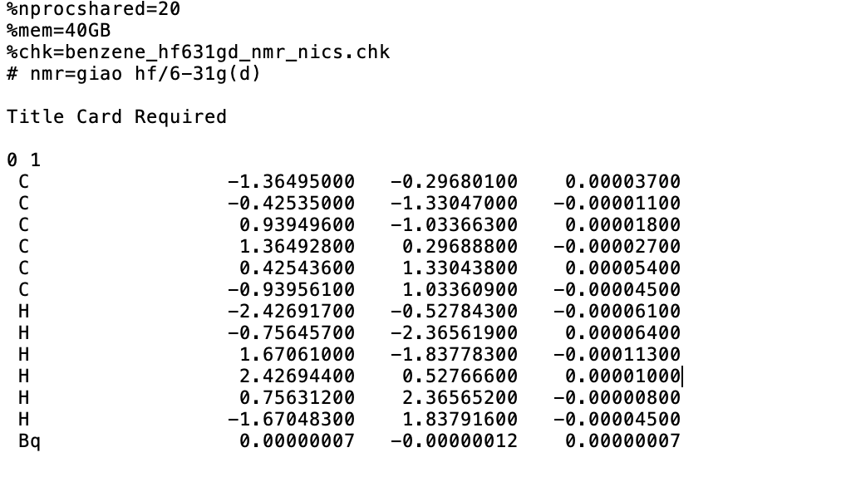Gaussian input files have a variety of parameters to allow users to specify intended calculation behavior. These include the number of processors and amount of memory to be used by the computer, the name of the checkpoint file for Gaussian to use, the basis set for Gaussian to use to conduct the calculation, and keywords specifying the exact type of calculation Gaussian will perform (Fig. 5). The number of processors and amount of memory specify the amount of computational resources Gaussian will set aside for performing the calculation, both of which affect the speed with which the calculation will be carried out. These parameters are of course necessarily limited by the memory and number of processors that the particular computer running the Gaussian calculation actually has. The checkpoint file is a machine readable file that contains the results of a Gaussian calculation, and the checkpoint file parameter in an NMR

**Figure 5.** Gaussian input file for determining the absolute magnetic shielding about the centroid of benzene. Parameters of note are processor and memory allocation, checkpoint file name, calculation keyword, and basis set. Bq denotes the probe proton at the centroid.

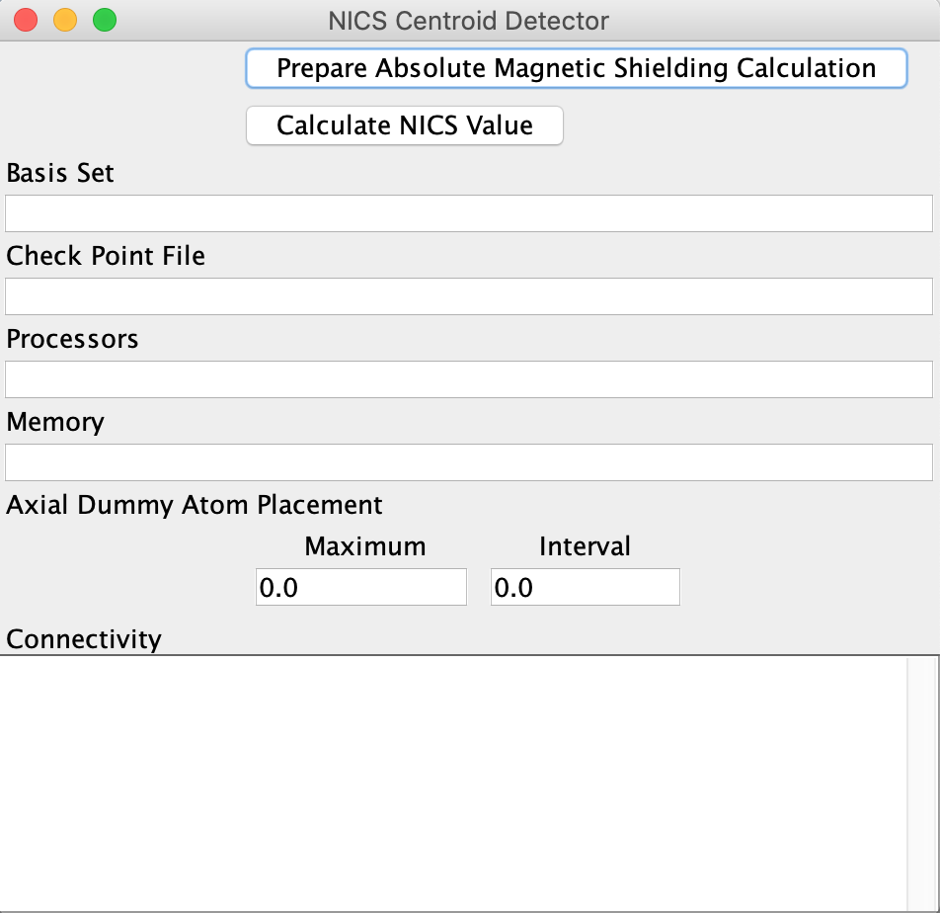calculation input file indicates the file name that the resulting checkpoint file will be saved under. Often times, checkpoint files are used to conduct additional calculations due to their easy readability by Gaussian. The calculation parameter specifies the exact calculation Gaussian will perform with the provided data, and for the purposes of this program, this parameter will always be nmr = giao or Nuclear Magnetic Resonance Gauge Independent Orbital method. The last parameter provided by the input file specifies the wave function approximation and basis set, indicating the level of theory that the calculation will be performed at. For example, a parameter of hf/6-31g(d) indicates that the 6-31g(d) basis set with Hartree-Fock approximation will be used to carry out the NMR calculation. These parameters satisfy Gaussian’s requirements for carrying out an NMR calculation, and the user interface has been designed to allow easy specifications of these parameters and those additional needed by the program (Fig. 6).

**Figure 6.** NICS Centroid Detector’s initial window with the required parameters to locate the centroids and the two features the program offers.

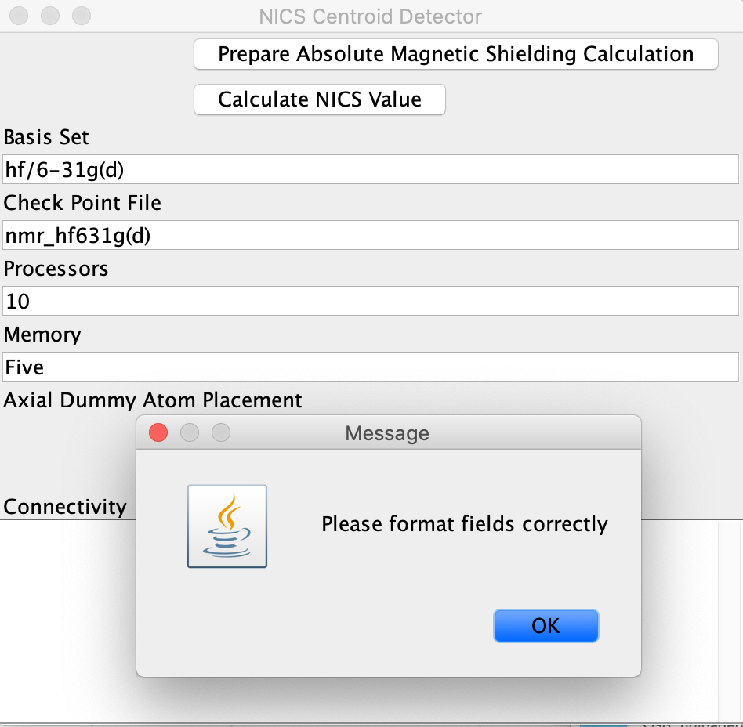The four initial fields specify the inputs required by Gaussian to complete the NMR calculation. The fifth parameter, axial dummy placement, allows the user to place dummy atoms along the line normal to the center of each ring with the Maximum field indicating the total distance of dummy atom placement and the interval indicating the frequency. Dummy atom placement is mirrored about the best-fit plane approximation of the points composing the ring. Last, the connectivity field takes as input the connectivity of the molecule and allows copy-paste and scrolling functionality. All of these fields were implemented with a combination of Java Swing components JFrame, JPanel, JTextArea, and JLabel. These fields are designed to only accept

**Figure 7.** Visualization of the error window that occurs with incorrect data entry. This particular error is caused by the entry of “Five” into the memory field instead of 5.

valid entries. If the user does not enter a positive real number in the processors, memory, and axial dummy atom placement fields and valid inputs into the others then the user will not be able to proceed past the main window (Fig. 7). Instead, a new window requesting that the user format fields correctly will appear, requiring they fix any entry errors before proceeding with the computation. This error screening process is necessary because the program interprets the entries in each field as a particular data type, so incorrect entry at the initial step could cause additional errors if the program is allowed to proceed into computation. Upon correct entry of the input fields and selection of “Prepare Absolute Magnetic Shielding Calculation,” the operation of the program proceeds according to figure 2. After specifying the save file location, the program runs and saves the correctly formatted Gaussian input file to the specified location in the file directory system. The program then returns the user to the original window with the parameters from the previous calculatino still in their fields in case the user wants to generate a slightly different input file based upon the same parameters. This behavior completes the user interactive options for the NICS Centorid Evaluator.

## Data Parsing

Parsing information from the inputted log file is a necessary first step to allow computation of the centroids associated with each ring in the molecule of focus. This functionality was achieved with the use of Java’s built in Buffered Reader component which allows line by line inspection of the elements of a text file. The three-dimensional coordinates of each atom within the molecule are the first vital pieces of information retrieved from the log file. In a Gaussian optimization file, the coordinates for the atoms are contained by the input orientation section, and the program proceeds by reading lines one by one in the file, trimming all white space, and inspecting the resulting string until it receives “Input orientation:.” This string signals the beginning of the coordinate information. Each line of the input orientation section contains the 3 coordinates for each atom separated by white space, so the program proceeds by splitting the line by white space to get the 3 distinct elements, converting each element into a double, placing those elements into an ArrayList that represents the coordinates for the particular atom the line in the input orientation represents. This ArrayList is added to a larger ArrayList with type ArrayList<ArrayList<Double>> that contains all of the coordinate data for the molecule and allows easy reading and traversal of that information. Charge and multiplicity are additional information provided by the log file that Gaussian requires to perform its NMR calculation. These two values can be determined in a similar manner to the coordinates of the molecule by traversing the log file for the string “Charge” and isolating and storing the following values as integers. Charge, multiplicity, and coordinates are the only values that this program requires from the log file, so obtaining these values completes log file parsing.

## Connectivity Organization

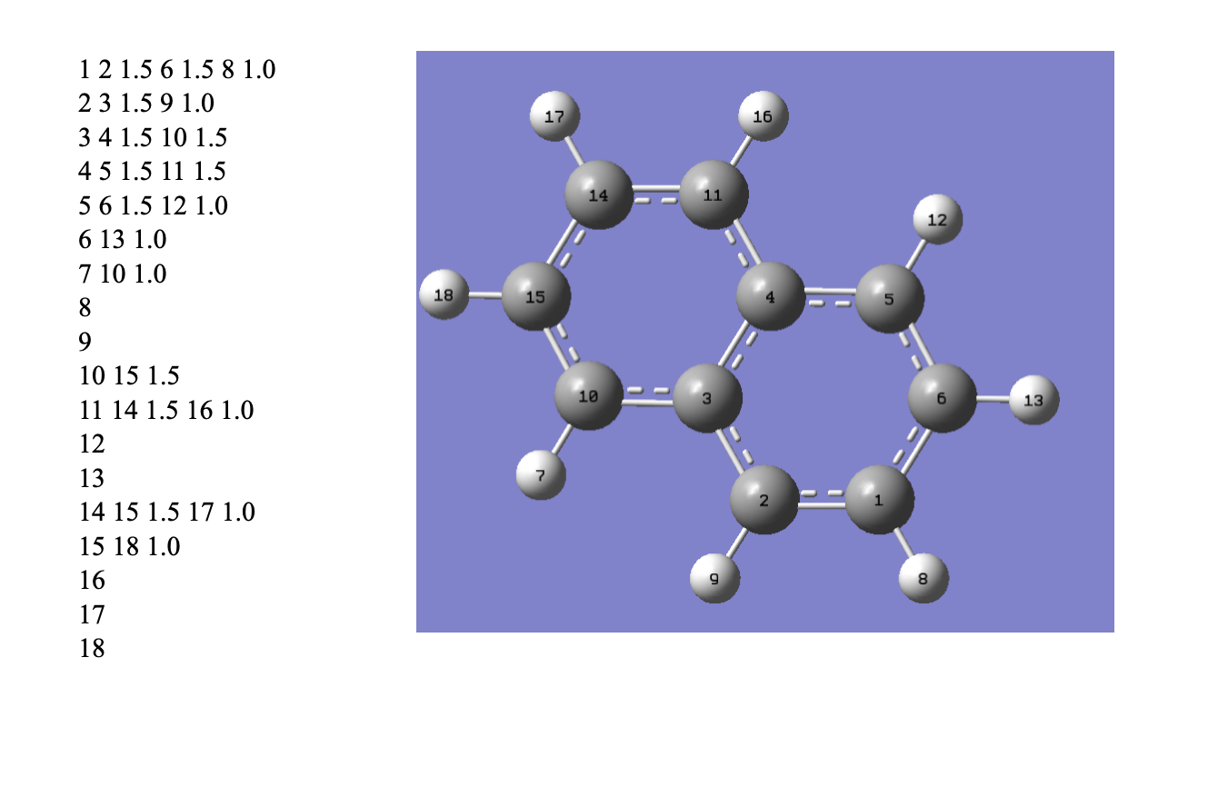The connectivity information provided by the user is the essential artifact that the program uses to identify cycles and then place probe protons at their centroids. Careful management of the

**Figure 8.** Visualization of napthalene and its associated connectivity chart

organization and storage of this information is thus important to make computation as easy and efficient as possible. The connectivity information that Gaussian provides to represent a molecule is as concise as possible while still representing every atom and bond within the molecule. In a connectivity chart, each atom has its own row which lists every bond the atom shares with another atom that has not yet been listed earlier in the chart. The ordering of each row in a connectivity chart begins with the number of the atom the row refers to, the number of an atom the atom of focus is bonded to, the strength of that bond, and so on. For example, in the case of naphthalene, the very first atom is bonded to atoms 6, 2, and 8, so the corresponding row in the connectivity chart reads “1 2 1.5 6 1.5 8 1.0” (Fig. 8). The bond strengths are 1.5 for 2 and 8 because the coneections between 1 and 2 and 1 and 8 are part of a delocalized pi system, and the bond strength is 1.0 for the bond between 1 and 8 because they share a single bond. As these three bonds are listed under the row for in the connectivity chart for the first atom in the molecule, note that these bonds are not listed elsewhere. Neither 2, 6, nor 8 have rows in the chart that reference their bond with 1 which is in keeping with the connectivity chart’s prioritization of brevity.

The program receives the connectivity information as a single string, so decomposition into meaningful pieces of information begins by splitting the string by new lines. Each of these new lines is then split by white space to isolate the individual values indicating bonds and atoms into ArrayLists. Because this program only needs information about the existence and not the strength of the bond, each line is parsed by obtaining every other value starting with the second value in the particular row of the chart. These values, the atoms that the particular atom indicated by the chart are bonded to, are placed into an ArrayList which is subsequently placed into another ArrayList of type ArrayList<ArrayList<Integer>> to organize the connectivity information. The final product of this process is an ArrayList where the *i*th element contains an ArrayList of all of the atoms that are bonded to the *i*th atom in the molecule. While this process does effectively represent the meaningful information within the connectivity chart, it does not provide sufficient information for successful data traversal due to its tendency for brevity as mentioned earlier. Effective visualization of the molecule as a graph requires that each entry in the ArrayList

*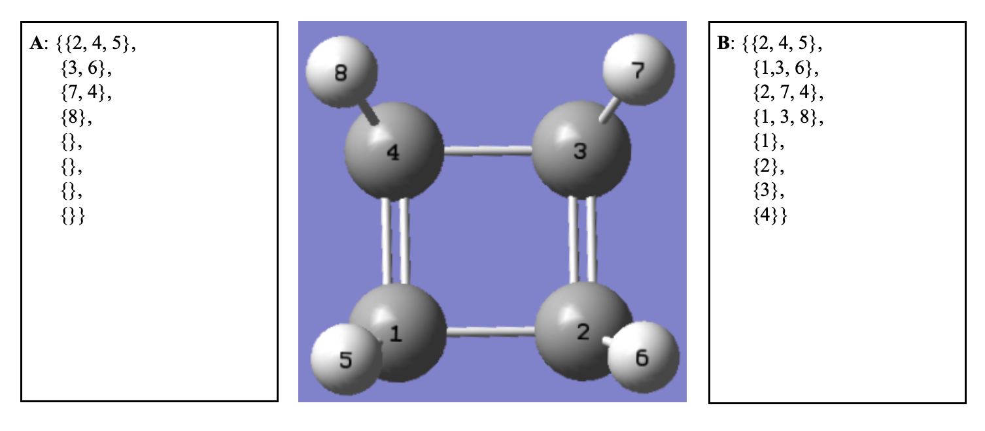***Figure 9.** Visualization of cyclobutadiene and two methods for representing its connectivity. **A.** Gaussian’s concise representation. **B.** A complete representation

contain all atoms that are connected to the atom that entry represents and not only those connections that have not yet been represented by a previous entry. This requirement is the case because most graph traversal algorithms use a list that has all of the nodes a node is connected to rather than a list that has some of the nodes a node is connected to with additional nodes listed elsewhere in the list. Thus, the next step the program performs is to convert Gaussian’s connectivity representation into one more usable for graph representation and traversal algorithms.

This process is performed by traversing each entry in the list of lists representation of Gaussian’s connectivity chart. For each atom *a* in the list representing the atoms connected to atom *i*, the program checks if atom *i* is included within the corresponding list for atom *a.* If *i* is not included, then *i* is added to atom *a*’s list. This process continues for every edge represented by the list of lists until a complete connectivity chart is contained with every entry indicating all of the corresponding atom’s connections. For example, in the case of cyclobutadiene, Gaussian’s connectivity chart only gives atoms 3 and 6 as connections for atom 2 because the connection between atom 1 and 2 was already listed in the list for atom 1 (Fig. 9). The program amends this by first traversing the list for atom 1, noting that atom 1 is not included in the list for atom 2, and adding atom 1 to atom 2’s list and so on. After creating a full connectivity representation of the molecule, the program has sufficient information to represent the molecule as a graph and proceeds with cycle identification.

## Horton’s Algorithm

As mentioned earlier, cycle identification is performed by creating a graph representation of the molecule and finding the minimum cycle basis for that graph where the minimum cycle basis is the smallest set of cycles that can be used to construct all cycles within the graph. Horton’s algorithm effectively determines the minimum cycle basis in a sequence of four critical operations.

### Determine the Shortest Path between Every Combination of Two Nodes

Determining the shortest path between every combination of two nodes is a necessary first step for Horton’s algorithm because later steps rely upon these shortest paths for cycle identification. There are many different algorithms for determining the shortest path between every combination of two nodes within a graph, and a generally effective and commonly used on is Dijkstra’s algorithm. Dijkstra’s algorithm computes the shortest path between a starting node and every other node in the graph and makes use of an adjacency matrix and the starting node as inputs. An adjacency matrix is a matrix where each row represents one node in the graph and has as many columns as there are nodes in the graph. The *i*th row of the matrix represents the *i*th node in the matrix, and for every node *j* that node *i* shares an edge with there is a one in the *j*th column. In the corresponding columns for nodes that *i* does not share a column with, there are zeroes. Basically, an adjacency matrix has a row for every node in a graph and each edge (*a,b*) places a one in the corresponding column for *b* in the corresponding row for *a* and a zero otherwise. The adjacency matrix is constructed for the molecule by using the full connectivity 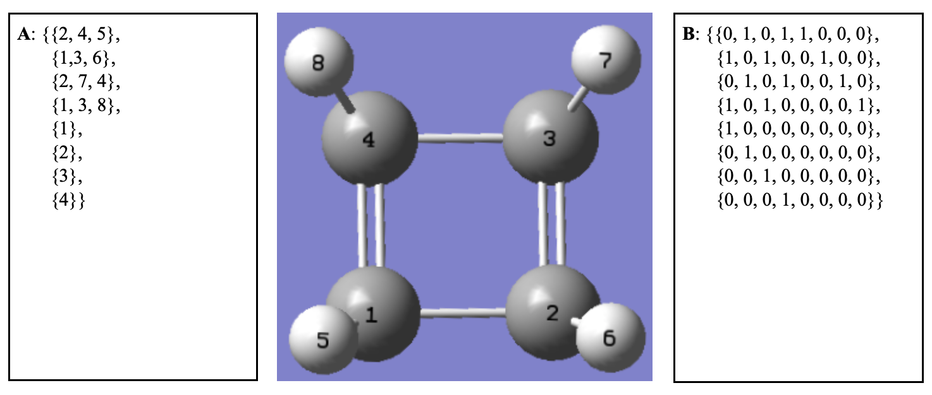determined from Gaussian’s connectivity chart and an ArrayList of ArrayLists. An ArrayList of

**Figure 10.** Visualization of cyclobutadiene with **A.** The full connectivity chart for the molecule and **B.** the corresponding adjacency matrix.

ArrayLists can be used as an effective way to represent a matrix by making the inner most ArrayList the values that would be found in a row of the matrix. As a result, the *i*th element of the *j*th ArrayList is equivalent to the value found at the *i*th column and *j*th row in a matrix. The adjacency matrix is created by initializing an ArrayList with a size equivalent to the number of nodes in the graph or atoms in the molecule and filling it with ArrayLists of size equivalent to the size of the graph with every entry occupied by a zero. The adjacency matrix is made complete by traversing the full connectivity chart and placing a one at the row and column corresponding to the two elements sharing an edge (Fig. 10).

Once the adjacency matrix has been determined, the program uses Dijkstra’s algorithm to compute the shortest paths between a starting node and every other node in the graph. Dijkstra’s Algorithm makes use of 3 data structures during its computation:

* An array *d* of equivalent size to the graph that holds the distances between the starting node and the node corresponding to each cell. Array *d* is initialized such that the cell corresponding to the starting node is 0 and all other cells are infinity.
* A list *l* that contains every node in the graph.
* A set *s* that is initialized to empty that keeps track of visited nodes.
* An array of arrays *p* initialized to empty except for the array corresponding to the starting node that will hold the shortest paths. The array corresponding to the starting node is initialized to an array of size 1 containing only the starting node.

With these data structures, Dijkstra proceeds as follows:

1. Given that *l* is not empty, remove the element *n* with the smallest distance value from *l* and add that node to *s*, indicating that the node has been visited.
2. Inspect all the distance values of nodes adjacent to *n.*
3. If the distance value for *n* plus 1, the distance between *n* and any of its adjacent nodes,is less than the distance value for any of its adjacent nodes, then *d* will be updated to *d*[*n*] + 1 for the corresponding node. Additionally, the array in *p* corresponding to the node *i* with the newly discovered shorter path will be updated to be equivalent to the path for *n p*[*n*] with *i* appended at the end.
4. Once list *l* is empty, the algorithm is complete with *p* containing all of the shortest paths between the starting node and every other node in the graph and *d* containing the distance of those paths.

In this manner, Dijkstra successfully determines the shortest paths within the graph; however, it only does so for a single starting node while Horton’s algorithm requires all of the shortest paths between every combination of two nodes. In order to achieve this, Dijkstra’s algorithm is run for every single node in the graph. At this point in the computation, the program has produced a list of list of lists where the topmost lists represent each set of shortest paths from a particular starting node and the bottommost lists contain the shortest path from the starting node to the node that the each bottommost list corresponds to. Basically, at this stage the program has created a representation of the graph that provides the shortest path to get to any node from any other.

### Determine All Cycles within the Graph

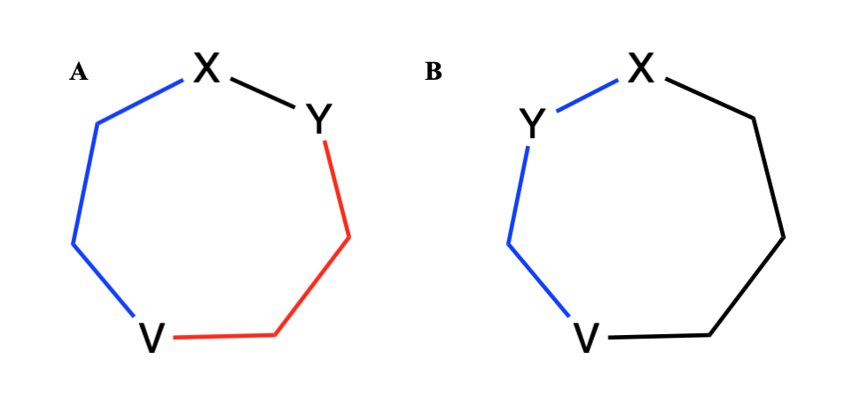Once the shortest paths between every combination of two nodes have been determined, Horton’s algorithm proceeds to identification of all cycles within the graph. For every combination of an edge (*x,y*) and a node *v,* the program examines the shortest path between *x* and *v P(x,v)* and the shortest path between *y* and *v P(y,v).* If the only shared node between *P(x,v)* and *P(y,v)* is *v,* then a cycle exists because *x* and *y* share an edge and there are two unique paths to *v* from connected nodes. If the two paths shared more elements than just *v*, then the paths must overlap at some point along their route to *v,* violating the definition of a cycle’s requirement for

**Figure 11.** Visualization of two combinations of an edge and a node in heptane with **A.** An edge and node combination that does result in Horton’s algorithm determining a cycle and **B.** And edge and a node combination that have overlapping paths that do not result in Horton’s algorithm determining cycle presence.

unique nodes and edges in a path. For example, in the case of the heptanes in fig. 11, A. shows the selection of *x, y,* and *v* such that *x* and *y’*s shortest paths to *v* take different routes that both end in *v.* B. however, due to the position of *x* and *y,* both have paths that share a number of elements other than *v.* The example of A. is sufficient to prove that a cycle exists for Horton’s algorithm, and while B. does not yield the determination of a cycle, it does not mean that a cycle could not exist containing *x, y,* and *v.* This subtlety between the two examples illustrates why every combination of an edge with a node must be inspected in order to find every cycle within 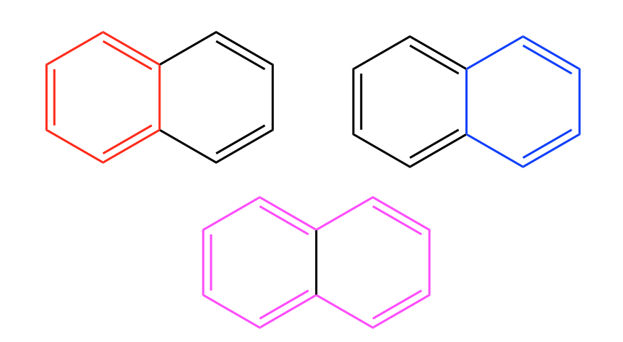the graph. This behavior is implemented in the program by iterating through the list of edges in

**Figure 12.** The three cycles that Horton’s algorithm will identify at step two of computation. Note that only the top two cycles are valid for the purposes of discovering the minimum cycle basis

the graph and inspecting all the shortest paths between the members of a particular edge and all other nodes in the graph for characteristics of a cycle. While this Horton’s algorithm at this stage in the process does identify all cycles in the graph, not all of these cycles are legitimate members of the minimum cycle basis because many of the cycles can be composed of other cycles the algorithm has discovered. In the case of naphthalene which contains two rings, Horton’s algorithm at this stage identifies both of the smaller rings as well as the larger ring which can be composed of the two smaller rings. The remaining steps in Horton’s algorithm are purposed toward identifying and removing those rings which may be composed of a linear combination of the smaller ring in order to obtain the minimum cycle basis.

### Sort the Cycles by Weight

This step is more important when using Horton’s algorithm with graphs with a more sophisticated sense of weight though is still a helpful step within this particular implementation. Oftentimes in graph theory, graphs have a weight assigned to their edges that specifies the cost required to move from one node to another. This characteristic affects computation of the shortest path between two nodes because the actual cost of traveling between the nodes is greater than the total number of nodes traversed. In this program’s use case, the weights of the nodes are all set at 1, so the weight of a cycle is simply the number of edges within the cycle. Horton’s algorithm requires that all cycles be sorted by weight at this point in computation because it eases computational burden later on in determining the linear independence of the cycles and ultimately the minimum cycle basis. The discovered cycles are sorted by size using Java’s built in Collections.Sort() method which uses an implementation of merge sort and are ready for minimum cycle basis determination.

### Minimum Cycle Basis Determination

At this step, Horton’s algorithm proceeds with pruning the current list of all cycles within the graph to achieve the minimum cycle basis. As stated earlier, the minimum cycle basis of a graph is the smallest possible set of cycles that can be used to construct all other cycles in the graph. As such, any cycle within the set of cycles at this stage in computation that contains another cycle in its entirety is not a member of the minimum cycle basis. This is the case because in order for a cycle *a* to contain another cycle *b* in its entirety either cycle *a* and *b* are equivalent or cycle *a* contains another cycle in addition to *b*. This quality means that cycle *a* can be composed of another identical cycle or the union of two or more other cycles, meaning cycle *a* cannot be a member of the minimum cycle basis. As such, the minimum cycle basis can be determined by removing all cycles that contain smaller cycles in their entirety. A HashSet is a data structure that allows add, remove, contains, and most importantly containsAll() functionality. ContainsAll is a method that checks if the HashSet contains all of the elements given as arguments to the containsAll() method. This data structure is used to determine the minimum cycle basis by iterating through the elements and for each cycle *i,* placing every other cycle into its own hashset. Using the containsAll method, if any of the HashSets contains cycle *i* in its entirety, then the cycle corresponding to that set cannot be part of the minimum cycle basis and is removed from the list of cycles. Testing for the inclusion of a subset of elements within another set is difficult because order is irrelevant within a set, so the using HashSet’s built in methods to test for inclusion improves the efficiency of the program. After iterating through all elements and comparing them with the HashSet versions of the other cycles, all invalid cycles have been removed and the minimum cycle basis obtained. While the program is effective in obtaining the minimum cycle basis and does so successfully, the minimum cycle basis does not exactly provide the molecular rings required for this program and had edge cases that needed addressing.

## Edge Cases

As state earlier, the minimum cycle basis is the smallest set of cycles that can be used to compose to compose all others within the graph. While this appears to provide the exact same set of cycles as demanded by the molecular context of this program, there are cycles that qualify as members of the minimum cycle basis that are not salient to the chemical context. These primarily occur in cycles that are so large that they do not contain all of the elements of any smaller cycle in their entirety. An example of this occurs in Buckminsterfullerene where there exists a member of the minimum cycle basis that traverses the perimeter of six hexagonal and pentagonal rings without containing any of smaller cycles’ elements in their entirety (Fig. 12). Note this membership in the minimum cycle basis is the case because each of the smaller rings contains a

**Figure 13.** Visualization of buckminsterfullerene and a cycle in purple that violates the requirements of the chemical context of this program. The carbons in blue highlight why this cycle was not eliminated by previous steps and was included in the minimum cycle basis

carbon that is not included in the path of the larger cycle. Because such a large cycle is not meaningful in terms of placing a dummy atom at its center, the program had to be modified to eliminate these cycles in addition to those that were not members of the minimum cycle basis. This problem was addressed by taking advantage of the fact that these larger cycles have intervening cycles within them with potential paths to follow. If any two nodes in the cycle have a shorter path between them than following the path of the cycle, then there exist smaller cycles within the larger that invalidate the cycle as a legitimate member of the chemical context. In the case of buckminsterfullerene, the two carbon atoms highlighted in blue in figure 14 have a shorter path between them than the path obtained by traversing the cycle in purple. To check for shorter paths, the program runs Dijkstra again to find the shortest paths between each combination of two nodes in each cycle. If any two nodes have a shorter path between them than simply following the cycle, then that cycle is removed from the set of legitimate cycles, effectively eliminating this edge case from occurring.

**Figure 14.** Visualization of two carbon atoms in blue that belong to the cycle in purple. The blue path in the second buckminsterfullerene illustrates the implementation of Dijkstra’s algorithm to discover intervening cycles.

## Centroid Identification and Dummy Atom Placement

After completing Horton’s algorithm and removing potential edge cases, all salient cycles within the graph have been determined, meaning that all rings have been identified and are ready for dummy atom placement. At this stage, the cycles are stored in a list of lists where each entry within the topmost list contains the atoms that compose a particular cycle. Additionally, the program also has the three-dimensional coordinates for each atom in the molecule and between these coordinates and the cycles has more than enough information to proceed with dummy atom placement. In Schleyer et al’s initial paper on NICS, the authors calculated the centroids of molecular rings manually by computing the unweighted average of the atoms within each ring. Calculating the unweight average of coordinates simply involves averaging each of the components, and this process occurs in the program by iterating through each cycle, obtaining the coordinates for each atom in the cycle, and averaging all coordinates to find the coordinates of the centroid. This calculation marks successful completion of dummy atom placement within the plane of a molecular ring.

## Axial Dummy Atom Placement

****Many researchers find it valuable to compute NICS values using dummy atoms placed above the center of the ring due to some theories that in-plane absolute magnetic shielding calculation is more impacted by local induced fields resulting from bonding and lone pair electrons instead of those from the delocalized electrons NICS seeks to evaluate.33 This program provides axial

**Figure 15.** Visualization of axial dummy atom placement in anthraces. The dummy atoms are placed 4 angstroms above and below the ring centers in with a spacing of 1 angstrom between dummy atoms.

dummy atom placement functionality based upon user input of the distance over which probe protons are placed and the interval of placement within that span. In order to place dummy atoms along the axis of the center of the ring, the normal vector for the plane on which the atoms in the ring lie must be determined. While it is simple to compute a plane and thus its normal vector given three points that lie upon that plane, many molecular rings are not planar. Calculating the normal vector for a nonplanar ring with the assumption that all of the ring’s atoms lie upon a plane would generate a normal vector not appropriate for placing axial dummy atoms. Indeed, given a large enough span of dummy atom placement, using a normal vector calculated with the 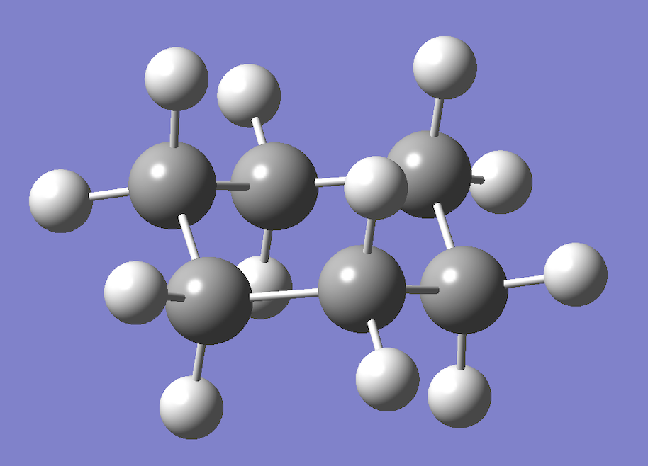assumption of ring planarity might eventually place dummy atoms outside the bounds of the

**Figure 16.** Visualization of the chair conformation of benzene, a cyclic molecule with atoms that do not lie upon a single plane

ring. In the case of archetypical cyclohexane in either its chair or boat conformation, selection of three adjacent atoms to compute the normal vector would generate a normal vector far from orthogonal to the ring center and not useful for axial dummy atom placement (Fig. 16). In nonplanar and planar rings, the normal vector can be calculated by computing every possible combination of 3 atoms in the ring. For 3 points on a plane, the normal vector is traditionally calculated by obtaining two vectors originating at one point that each end at one of the two other points. The normal vector is obtained by performing the cross product of the two vectors (Fig. 17). In this case where the planarity of the ring is not guaranteed, the normal vector is calculated for each of the possible combinations of 3 atoms in the ring. Once all of these normal vectors are calculated, averaging the normal vectors and dividing by the magnitude of the resulting vector determines the normal unit vector of the best-fit plane for the points in the ring. This averaged

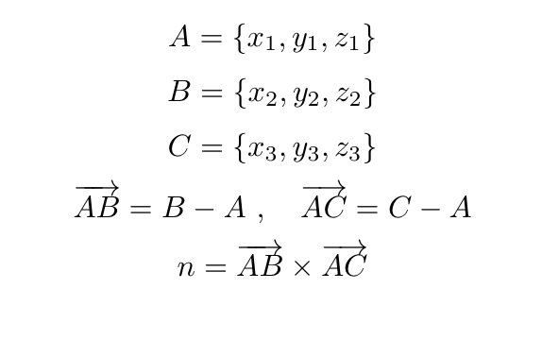normal unit vector can then be used to compute the axial dummy atoms by multiplying the vector

**Figure 17.** Process for computing the normal vector of a plane given three points that lie upon the plane

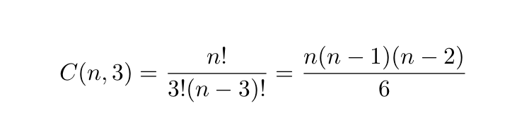by the number of angstroms the dummy atom is located above the ring and adding the vector to the already calculated centroid. This process of computing all possible combinations of 3 atoms within a ring does have a significant growth rate, meaning that computation will become less efficient as the size of the ring increases (Fig. 18); however, most molecular rings that the

**Figure 18.** Equation for combination for sets of 3 where n represents the number of atoms in the ring. Note that simplification of the combination equation yields a polynomial with a time complexity bounded by O(N3)

program will place axial dummy atoms for are less than 20 atoms in size and even a hypothetically enormous ring of 100 atoms would only have 161,700 combinations, a number still manageable if not ideal for the program.

At the moment, the program places axial dummy atoms symmetrically about the plane of the ring because it is not possible to establish a meaningful sense of the top and bottom or outside and inside without additional information. In the case of spherical molecules like buckminsterfullerene it is reasonable to do so without additional information; however, it is not sensible to allow users to choose orientation of dummy atom placement if it is only meaningful for particular molecules. The user could provide a coordinate that indicates the orientation of the molecule, but this requires more work on the user’s end to achieve unnecessarily specific results. Instead, the program automatically mirrors dummy atom placement across the plane of the ring to ensure that the user obtains the desired information even if the program does generate ultimately extraneous data points. At this point in computation, all calculations have been performed for dummy atom and axial dummy atom placement and all necessary coordinates have been retrieved.

## Gaussian Input File Generation

With all calculations completed, the program proceeds with the final step in its execution, creation of the Gaussian input file for performing the NMR calculation. All of the necessary arguments, memory, processors, checkpoint file, basis set, dummy atom coordinates, and the coordinates of the original atoms in the molecule, are passed to a new class FileCreator. The FileCreator organizes all of the parameters and required headings in order into an ArrayList of Strings for writing to a text file. Once organization into the ArrayList is completed, the program uses the Files.write() method to create a file with the name specified by the user in the specified location. The Files.write() method is used in this instance because it works for both of the operation systems the program is designed to run in, Mac OS and Windows. After this step, all required information has been written to a text gjf file, and the user may proceed with giving that file to Gaussian as input and running the nmr calculation. This step completes the functionality and operation of the program.

## Packaging the Program for Users

During the development process of this software, the program was almost always run using the IntelliJ IDE’s built in protocols for running java code. However, the user cannot be expected to download an application for editing and running java code simply to use this application primarily because it requires an unnecessary level of knowledge from users but also because it is a waste of time. IntelliJ allows export of java code to a jar file which allows running of the program simply by clicking it. While jar files are easy for users to run in Mac OS, in windows jar files require more user intervention to run, typically by way of the command line. Again, this is an unacceptable amount of required user knowledge, so the jar file was repackaged as an exe file. An exe file can be run in windows by clicking upon it, and repackaging was performed by another application launch4J in order to provide the windows counterpart for the mac-compatible jar file. These files require no installation and only need be downloaded in order for users to run them. While this is currently not the case, the files will be stored on a website with information about NICS, aromaticity, and the programs themselves in order to allow easy user access to the software.

# Results

## Centroid Identification and Probe Proton Placement

**Table 1.** Centroids calculated manually and by the NICS Centroid Evaluator

|  |  |  |
| --- | --- | --- |
| Molecule | NICS Centroid Evaluator | Calculated |
| Benzene | (0.00, 0.00, 0.00) | (0.00, 0.00, 0.00) |
| Cyclobutadiene | (0.00, 0.00, 0.00) | (0.00, 0.00, 0.00) |
| Cyclopentadiene | (-1.679, -0.015, 0.369) | (-1.679, -0.015, 0.369) |
| Anthracene (left) | (-8.263, -0.863, -0.016) | (-8.263, -0.863, -0.016) |
| Anthracene (right) | (-4.044, 1.617, -0.007) | (-4.044, 1.617, -0.007) |
| Anthracene (middle) | (-6.153, 0.377, -0.014) | (-6.153, 0.377, -0.014) |
| Buckminsterfullerene (1) | (0.144, 0.340, 0.000) | (0.144, 0.340, 0.000) |
| Buckminsterfullerene (2) | (0.144, -1.68, -0.611 | (0.144, -1.68, -0.611 |
| Buckminsterfullerene (3) | (-1.738, -0.747, -0.830) | (-1.738, -0.747, -0.830) |
| Buckminsterfullerene (4) | (2.025, -0.747, -0.830) | (2.025, -0.747, -0.830) |
| Buckminsterfullerene (5) | (1.895, 1.351, -0.612) | (1.895, 1.351, -0.612) |

Testing the functionality of the program proceeded by first evaluating the program’s effectiveness at centroid identification. A variety of monocyclic and polycyclic species with rings from four to six atoms in size were selected to evaluate centroid detection performance. The chosen molecules were created in GaussView 16 and were optimized with MP2/6-31G(d) to generate log files for the program to analyze. The log files for each molecule were used as inputs for the NICS Centroid Evaluator, and the outputted centroid coordinates were retrieved from the output gjf file under the rows for ghost coordinates (Table 1). In the case of buckminsterfullerene, because the molecule has 60 atoms and 32 faces, five particular centroids were randomly selected to evaluate centroid perception performance. Once experimental values were obtained from the NICS Centroid Evaluator, the coordinates associated with the atoms from each ring were obtained from their corresponding log file. These values were used to compute an unweighted average of the coordinates of each atom in each ring in order to obtain theoretical values for the centroids. The centroids calculated by the NICS evaluator were identical in every

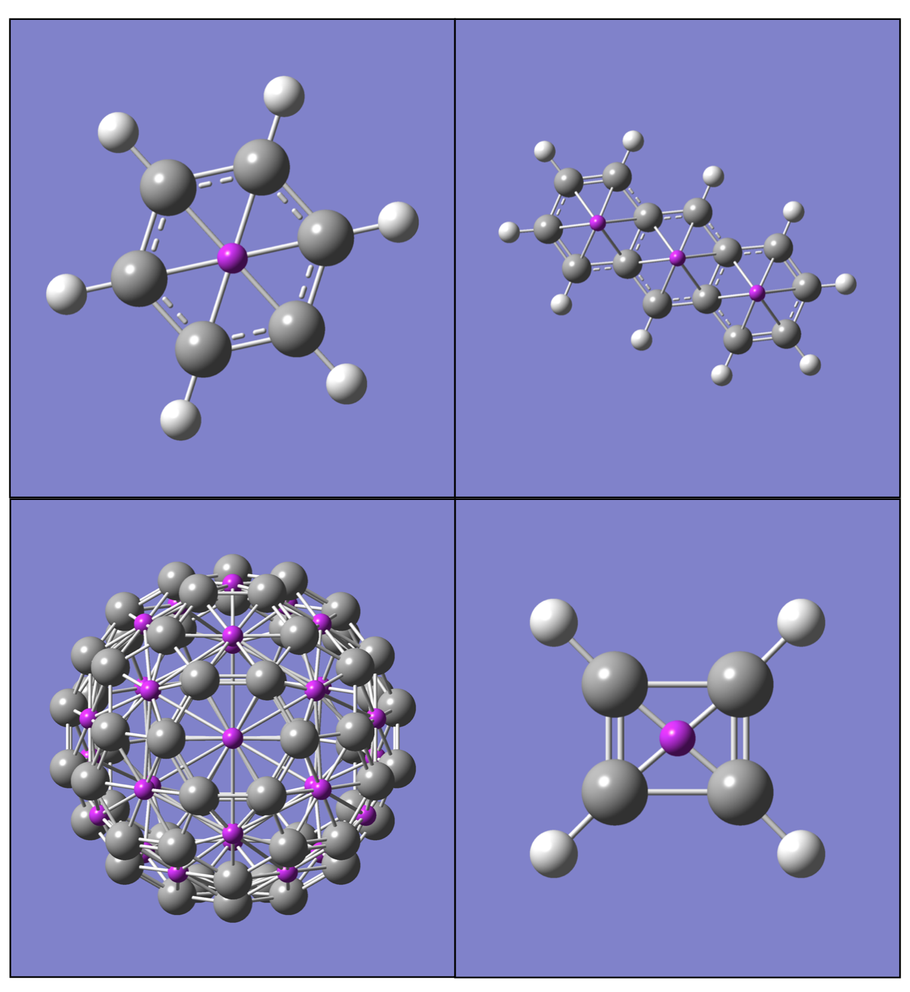case to those calculated manually which indicates successful calculation of centroids and also

**Figure 19.** Results of dummy atom placement at the centroids of the rings in benzene (top left), naphthalene (top right), buckminsterfullerene (bottom left), and cyclobutadiene (bottom right) visualized with GaussView.

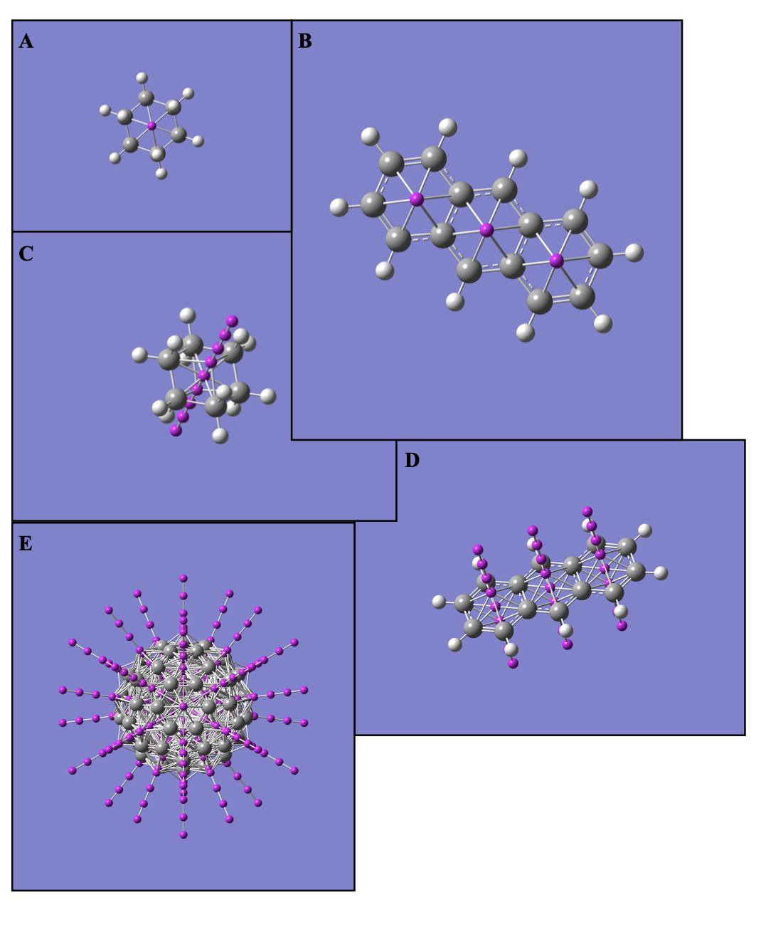**Figure 20.** Visualization of axial dummy atom placement of span 4 angstroms with 1 angstrom spacing in **A.** Cyclohexane from an axial view **B.** Anthracene from an axial view **C.** Cyclohexane from a nonaxial view **D.** Anthracene from a nonaxial view **E.** Buckminsterfullerene

necessarily indicates effective ring perception by the program.

As dummy atom placement simply requires labeling of centroids with Bq notation in a

Gaussian file, successful centroid determination also indicates successful dummy atom placement so long as Gaussian’s syntactical requirements in generating input files are followed correctly. The coordinates calculated by the NICS Centroid Evaluator were placed into GaussView in order to visualize dummy atom placement performance (Fig. 19). As with the calculated and theoretical results, visualization of dummy atoms within a variety of molecules

shows placement as expected within the center of each ring.

Axial Dummy atom placement performance was evaluated by optimizing a variety of molecules using the MP2/6-31G(d) level of theory in Gaussian and inputting them into the NICS Centroid Evaluator with a placement span of four angstroms and an interval of one angstrom. NOTE to REVIEWERS: I have not yet done the math to compare the axial dummy atom placement results with theoretical values, but I intend to do so. Upon completion of computation by the evaluator, the coordinates of each molecule’s atoms and dummy atoms were placed into GaussView to visualize effectiveness of placement (Fig. 20). Though certainly not quantitative, these visualizations show dummy atoms placed ostensibly along a single axis perpendicular to the plane of the ring. When viewed axially with the image taken perpendicular to the plane of the ring, the dummy atoms are all concealed by dummy atom nearest to the point of image capture.

## Gaussian NMR Input File Creation and NICS Results

While centroid detection and dummy atom placement are essential for correct functioning of the application, generation of input files that run Gaussian calculations correctly are necessary to complete the functionality of the application. The NICS Centroid Evaluator was run for a variety of different organic cyclic molecules and generated the corresponding Gaussian input files with

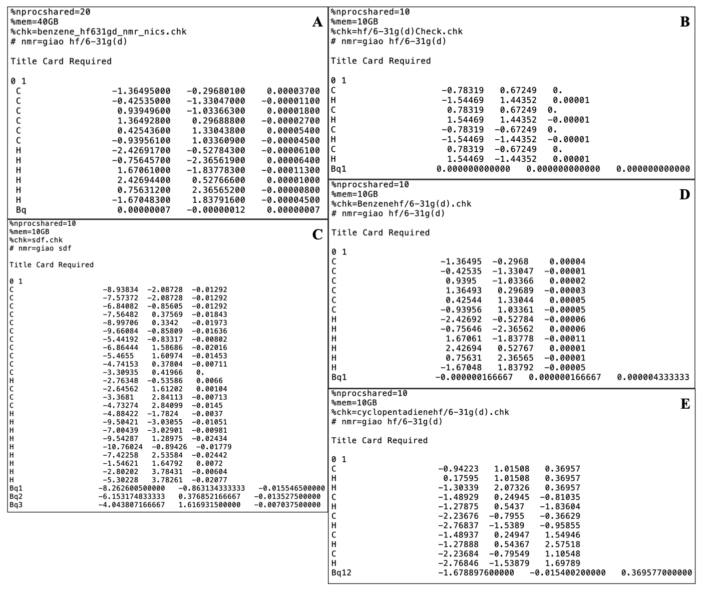the basis sets hf/6-31G(d) and hf/6-31+G(d). These input files were correctly formatted in terms

**Figure 21.** Exemplar Gaussian in put file generated by Gaussian for **A.** Benzene and Gaussian input files generated by NICS Centroid Evaluator for **B.** Cyclobutadiene **C.** Anthracene **D.** Benzene **E.** Cyclopentadiene

of the syntax required by Gaussian and order all parameters and coordinates accurately with the appropriate spacing between them. All of the input files generated by the program ran successfully and yielded standard output files with associated NICS Values for the dummy atoms (Table 2.). Most experimental values differed from those in the literature by a reasonably large amount excepting those of benzene and those in anthracene and cyclobutadiene for the hf/6-31G(d) basis set.

**Table 2.** NICS values calculated from NICS Centroid Evaluator input files vs. literature values

|  |  |  |  |  |
| --- | --- | --- | --- | --- |
|  | Experimental |  | Schleyer et al. |  |
| Molecule | hf/6-31G(d) | hf/6-31+G(d) | hf/6-31G(d) | hf/6-31+G(d) |
| Benzene | -11.54 | -9.74 | -11.5 | -9.7 |
| Cyclobutadiene | 28.85 | 30.6 | 28.8 | 27.6 |
| Anthracene (middle) | -14.38 | -13.22 | -14.3 | -13.3 |
| Anthracene (side) | -9.38 | -7.97 | -9.6 | -8.2 |
| Cyclopentadiene | -4.34 | -3.34 | -4.2 | -3.2 |
| Cyclohexane | -1.7 | -1.8445 | -2.1 | -2.2 |

# Discussion and Conclusions

## Centroid Detection, Cycle Identification, and Dummy Atom Placement

Calculation of centroids for a variety of different molecules yielded centroid coordinates for comparison with actual centroid values calculated from the ring coordinates (Table 1). All centroids calculated by the program were identical to their actual values, indicating successful centroid identification and by extension successful cycle detection. Dummy atom placement proceeds by simply denoting the atom as a ghost atom and adding the associated coordinates to the Gaussian input file, so successful centroid determination also indicates successful dummy atom placement.

Centroid determination accuracy and its necessary implication of cycle perception success also have various implications about the methods used in performing cycle perception itself. As all rings in the tested species were identified, the modified minimum cycle basis is therefore a legitimate model for representing the chemically salient within this set of molecules. Additionally, these results confirm the effectiveness of Horton’s algorithm in determining the minimum cycle basis and also that implementation of the Horton’s algorithm was successful as well.

Axial dummy atom placement is also effective in this program as visualizations of axial placements show dummy atoms placed uniformly along the vector normal to the plane. This success is shown particularly well by accurate axial placement in cyclohexane which has a fairly nonplanar organization of its compositional atoms. Successful placement within the context of cyclohexane thus indicates that the plane and normal vector approximation methods are effective in both planar and nonplanar contexts.

The success of dummy atom placement within this set of molecules indicates the program’s functionality for determining rings of varying sizes, rings that share a bond with adjacent rings, rings in molecules with a large number of atoms and rings, rings with nonplanar geometry, and other rings in molecules with various peculiarities. There are of course many molecules with various novel structural features that still need to be tested; however, there is no reason to expect at this time that the program is not broadly applicable to a wide variety of molecules given its early success with a somewhat varied data set.

While all desired centroids were discovered in the tested molecules, there was one case in which additional centroids were found that were not expected in terms of the intended functioning of the molecule. In the case of buckminsterfullerene, computing the centroids with the program yielded several dummy atoms on the inside of the spherical molecule in addition to all 32 centroids in its rings. These centroids were determined because buckminsterfullerene has several graphically and chemically significant rings that traverse the outer perimeter of the molecule (Fig. 22). However, these are completely legitimate chemical rings whose absolute magnetic shielding some researchers may want to study, so the program continues to include these centroids even if they may be extraneous to some users.



**Figure 22.** Visualization of the cycle in buckminsterfullerene that traverses the perimeter of the molecule and generates an internal centroid

## Input File Generation and NICS Determination

The program successfully generates text files in the location specified by the user and containing the calculated centroids along with the necessary parameters for Gaussian. Gaussian has successfully run and completed all calculations begun by input files generated by the NICS Centroid Evaluator, indicating that the input files the program creates are perfectly legitimate. These calculations generated a variety of NICS values for the species tested that varied by a fairly significant amount with the literature values obtained by Schleyer et al. However, this discrepancy does not necessarily mean that the values calculated by this study are incorrect. Indeed, given that the centroids calculated are mathematically exact and that the Gaussian input files are correctly formatted, the values retrieved by this study are identical to what a researcher would find if they were to place the dummy atoms and perform the Gaussian calculation manually. As a result, the discrepancy between the experimental values from this study and those of Schleyer et al. indicate a dichotomy between modern NICS calculation methods and Schleyer’s rather than a programmatic error. There are a variety of reasons that this difference exists between the literature and Gaussian’s results. The first could be that Schleyer et al. used a different basis set for optimizing the geometry of the molecules which yielded slightly different coordinates for the points, a slightly different location for the centroids, and then a slightly different result from the nmr calculation. The second is that the study is over twenty years old and computational methods have likely changed over that time frame to yield more accurate results. Third, and least likely, is the possibility that Schleyer et al. simply made several mistakes at some point in their calculation of the centroids and computation of the absolute magnetic shielding. Regardless, as NICS denotes aromaticity in binary as antiaromatic if positive and aromatic as negative, the fact that none of the values from this study are opposite in sign to those of Schleyer’s indicate at the very least agreement on the aromatic character of the studied species if not their level of aromaticity.

## Future Work

In its current state, this program is an effective tool for NICS determination. It has correctly determined the centroids and axial centroids for every molecule it has been tested upon and generates appropriately formatted input files for Gaussian based upon those centroids. The evaluator makes NICS determination, particularly axial NICS determination, significantly easier for users because manual placement of dummy atoms within Gaussian or another program is laborious. However, while the main functionality has been achieved for the program, there is still more work to be done and potential features to add.

In terms of user interface and functionality, there are a couple of changes that could be made to the initial window to improve the user experience. Currently, if a user enters an invalid entry in one of the parameter fields, the program will not allow them to proceed to centroid calculation and input file generation; however, it does not specify exactly which field was entered incorrectly. There are likely use cases where a user is confused about what field they entered incorrectly, and a more specific error message would be helpful for allowing the user to address the syntactical mistake more quickly. Additionally, there are two fields, the checkpoint file name and the memory, that append .chk and GB respectively to the ends of the entries, meaning that users do not need and are not expected to add that terminology themselves. While the documentation will note this particular subtlety, it is not apparent on the main window of the program, so it would also be useful to provide clickable hints that indicate to the user the exact formatting required for effective operation of the program.

Another subtlety of the program is the formatting it requires for the connectivity field. Currently, the program takes the connectivity input as it appears in the Gaussian optimization file and experiences errors if it is any other form. For example, if there is any leading white space before the first integer in a row of the connectivity chart or a blank line in the middle of the connectivity, then the program terminates without finding the desired results. It would be useful if the program could be robust enough to handle these variations in the connectivity input or at the very least detect when the input is not in the correct format to alert the user beforehand. In the case that the user submits a connectivity that is correctly formatted but does not match the coordinates and atoms specified by the log file, then the program also terminates. Again, it would likely be helpful to the user if the program gave a more sophisticated reason for the failure other than returning to the main page without generating an output file particularly because users will assume that the program made an error rather than themselves if they are given no additional information.

Additional work remains to be done to give users access to the program and make the source code public for other developers. The current plan is to develop a website that has documentation for the application, an explanation of the theory and behavior of the program, and links for downloads by windows or Mac OS users. The source code will also be hosted on GitHub for inspection or use by other developers so that features can be added or code can be used to support other projects.

In terms of the utility and ease of use for potential users of the program and assuming that all users use Gaussian, the workflow for going from a structure in GaussView to a NICS value outputted by Gaussian is not completely ideal. The user must generate a file using GaussView, navigate to this program, input more information, generate another file, and then input that file into Gaussian to obtain a final output file that has the desired information. The most ideal workflow for NICS determination would be for this tool to be included inside of Gaussian. However, besides making the source code freely available, there is little the authors can do to encourage Gaussian to offer this feature due to its quality as a proprietary software package. There are of course other APIs like the chemistry development kit that currently do not have centroid identification, so the open source nature of this project will of course be useful beyond the bound of Gaussian.

# Acknowledgements

I’d like to thank Professors O’Leary and Fiebig for acting as my advisors during this project and providing frequent guidance that made this program effective and usable. I’d also like to thank the Chemistry department and Pomona College for providing the opportunity to conduct this research.

# References

(1) Balaban, A. T.; Oniciu, D. C.; Katritzky, A. R. Aromaticity as a Cornerstone of Heterocyclic Chemistry. *Chem. Rev.* **2004**, *104* (5), 2777–2812. https://doi.org/10.1021/cr0306790.

(2) Kekule, A. Lehrbuch Der Organischen Chemie.

(3) Studien über die s. g. aromatischen Säuren - Heidelberg - 1866 - Justus Liebigs Annalen der Chemie - Wiley Online Library https://onlinelibrary.wiley.com/doi/abs/10.1002/jlac.18661370309 (accessed Jan 23, 2020).

(4) Schleyer. Schleyer.

(5) Schleyer, P. von R. Introduction:  Aromaticity. *Chem. Rev.* **2001**, *101* (5), 1115–1118. https://doi.org/10.1021/cr0103221.

(6) Chattaraj, P. K.; Sarkar, U.; Roy, D. R. Electronic Structure Principles and Aromaticity. *J. Chem. Educ.* **2007**, *84* (2), 354. https://doi.org/10.1021/ed084p354.

(7) Aihara, J. Why Aromatic Compounds Are Stable. *Sci. Am.* **1992**, *266* (3), 62–69.

(8) Antić, M.; Furtula, B.; Radenković, S. Aromaticity of Nonplanar Fully Benzenoid Hydrocarbons. *J. Phys. Chem. A* **2017**, *121* (18), 3616–3626. https://doi.org/10.1021/acs.jpca.7b02521.

(9) Lloyd, D. What Is Aromaticity? *J. Chem. Inf. Comput. Sci.* **1996**, *36* (3), 442–447. https://doi.org/10.1021/ci950158g.

(10) Barquera‐Lozada, J. E. The Vorticity of the Current Density Tensor and 3D-Aromaticity. *Int. J. Quantum Chem.* **2019**, *119* (8), e25848. https://doi.org/10.1002/qua.25848.

(11) Chen, Z.; King, R. B. Spherical Aromaticity:  Recent Work on Fullerenes, Polyhedral Boranes, and Related Structures. *Chem. Rev.* **2005**, *105* (10), 3613–3642. https://doi.org/10.1021/cr0300892.

(12) Structural Aspects of Aromaticity | Chemical Reviews https://pubs.acs.org/doi/10.1021/cr990326u (accessed Jan 23, 2020).

(13) Glukhovtsev, M. Aromaticity Today: Energetic and Structural Criteria. *J. Chem. Educ.* **1997**, *74* (1), 132. https://doi.org/10.1021/ed074p132.

(14) What is… aromaticity: a critique of the concept of aromaticity—can it really be defined? - Chemical Communications (RSC Publishing) DOI:10.1039/B816811C https://pubs.rsc.org/en/content/articlehtml/2009/cc/b816811c (accessed Jan 24, 2020).

(15) Gershoni-Poranne, R.; Stanger, A. Magnetic Criteria of Aromaticity. *Chem. Soc. Rev.* **2015**, *44* (18), 6597–6615. https://doi.org/10.1039/C5CS00114E.

(16) Merino, G.; Heine, T.; Seifert, G. The Induced Magnetic Field in Cyclic Molecules. *Chemistry* **2004**, *10* (17), 4367–4371. https://doi.org/10.1002/chem.200400457.

(17) Gomes, J. A. N. F.; Mallion, R. B. Aromaticity and Ring Currents. *Chem. Rev.* **2001**, *101* (5), 1349–1384. https://doi.org/10.1021/cr990323h.

(18) Hall, G. G.; Hardisson, A. Ring Currents and Their Effects in Aromatic Molecules. *Proc. R. Soc. Lond. Ser. Math. Phys. Sci.* **1962**, *268* (1334), 328–338.

(19) Steiner, E.; Fowler, P. W. Patterns of Ring Currents in Conjugated Molecules:  A Few-Electron Model Based on Orbital Contributions. *J. Phys. Chem. A* **2001**, *105* (41), 9553–9562. https://doi.org/10.1021/jp011955m.

(20) Johnson, A. W. Aromatic Character. *Sci. Prog. 1933-* **1965**, *53* (211), 447–454.

(21) Nucleus-Independent Chemical Shifts:  A Simple and Efficient Aromaticity Probe | Journal of the American Chemical Society https://pubs.acs.org/doi/10.1021/ja960582d (accessed Sep 25, 2019).

(22) Stanger, A. Reexamination of NICSπ,Zz: Height Dependence, Off-Center Values, and Integration. *J. Phys. Chem. A* **2019**, *123* (17), 3922–3927. https://doi.org/10.1021/acs.jpca.9b02083.

(23) Szymanski, S.; Majerz, I. Aromaticity and Electron Density of Hypericin. *J. Nat. Prod.* **2019**, *82* (8), 2106–2115. https://doi.org/10.1021/acs.jnatprod.8b00872.

(24) Kaur, A.; Kour, M.; Gupta, R.; Bansal, R. K. Aromaticity of 1,4-Dehydrotropylium Ion and Its Mono- and Poly-Phospha Analogues. *Phosphorus Sulfur Silicon Relat. Elem.* **2017**, *192* (6), 674–682. https://doi.org/10.1080/10426507.2017.1284839.

(25) Anafcheh, M.; khodaei, N.; Zahedi, M. Formation of Boron Nitride Islands in the Graphene Nanoflakes: A DFT Study. *Mater. Chem. Phys.* **2019**, *223*, 164–170. https://doi.org/10.1016/j.matchemphys.2018.10.056.

(26) Lipkowitz, K. B.; Boyd, D. B. *Reviews in Computational Chemistry*; John Wiley & Sons, 2009.

(27) BufferedWriter (Java Platform SE 7 ) https://docs.oracle.com/javase/7/docs/api/java/io/BufferedWriter.html (accessed Nov 14, 2019).

(28) BufferedReader (Java Platform SE 8 ) https://docs.oracle.com/javase/8/docs/api/java/io/BufferedReader.html (accessed Nov 14, 2019).

(29) Mehlhorn, K.; Michail, D. Implementing Minimum Cycle Basis Algorithms. *J. Exp. Algorithmics* **2007**, *11*, 2.5. https://doi.org/10.1145/1187436.1216582.

(30) Bondy, J. A.; Murty, U. S. R. *Graph Theory*, 1st ed.; Springer Publishing Company, Incorporated, 2008.

(31) Berger, F.; Gritzmann, P.; de Vries, S. Minimum Cycle Bases for Network Graphs. *Algorithmica* **2004**, *40* (1), 51–62. https://doi.org/10.1007/s00453-004-1098-x.

(32) Horton, J. D. A Polynomial-Time Algorithm to Find the Shortest Cycle Basis of a Graph. *SIAM J. Comput.* **1987**, *16* (2), 358–366. https://doi.org/10.1137/0216026.

(33) Which NICS method is most consistent with ring current analysis? Assessment in simple monocycles - RSC Advances (RSC Publishing) DOI:10.1039/C8RA01263F https://pubs.rsc.org/en/content/articlehtml/2018/ra/c8ra01263f (accessed Apr 8, 2020).